
CYBERSTER
Internship Program - Batch 2
Week 6 - Mid-Term Assignment
TechNova Solutions: Enterprise Network Design Report
VLSM Subnetting • VLANs • ROAS • Static Routing • ACL Security
Intern Name: | Muhammad Raza (CT-24138)
Instructor Name: | Muhammad Huzaifa Riaz
Company: | CYBERSTER (Batch 2)
Task: | TechNova Solutions: Mid-Term Network Architecture
Date: | 1 August 2026

Table of Contents

Section
1. Company Scenario & Assignment Requirements | 3
2. Subnetting & IP Planning (VLSM) | 3
2.1 VLSM Methodology | 3
2.2 Subnet Calculation Results | 4
3. Network Architecture & Tier Identification | 5
3.1 Initial Topology Design | 5
3.2 Final Labelled Topology | 5
3.3 Device Role Justification | 6
4. Switch Configurations - VLANs & Trunking | 6
4.1 Access Switch 1 (Sales & IT) | 6
4.2 Access Switch 2 (Finance & HR) | 7
4.3 Distribution Switch | 7
5. Router Configurations - ROAS & Remote Branch | 8
5.1 Main Router - ROAS Sub-Interfaces | 8
5.2 Main Router - Remote Branch WAN Link | 8
5.3 Remote Branch Router | 9
6. Reachability & Access Control (Static Routing + ACLs) | 9
6.1 Remote Branch Default Route | 9
6.2 Main Router Static Route + Extended ACL | 10
7. Connectivity Verification - Ping Tests | 10
7.1 IT Department - Full Reachability | 10
7.2 Finance & HR - Restricted Reachability | 11
8. Conclusion | 12

1. Company Scenario & Assignment Requirements
TechNova Solutions requires a fully functional enterprise-grade local area network for a small branch office. The network must accommodate four internal departments with clearly defined host requirements, support remote branch connectivity, and enforce specific inter-departmental reachability policies through Access Control Lists.
Company Scenario: TechNova Solutions
TechNova Solutions is deploying a new local network infrastructure for a small enterprise branch. As the mid-term project for the internship, the task requires designing, subnetting, and configuring the network. A base network block of 192.168.10.0/24 was provided to accommodate four departments.
Base Network: 192.168.10.0/24 • 4 Departments • VLSM Required

# | Task | Deliverable
1 | Subnetting & IP Planning (VLSM) | Calculate Network Address, Subnet Mask, First/Last Usable IP, and Broadcast for each department using VLSM from 192.168.10.0/24.
2 | Network Architecture & Tier Identification | Design the topology in Cisco Packet Tracer. Label and group devices into Core, Distribution, and Access tiers.
3 | VLAN Creation & Switch Configuration | Create VLANs 10/20/30/40 for each department. Assign access ports. Configure trunk uplinks.
4 | Static Routing Setup | Deploy a Remote Branch router (192.168.20.0/24) connected via a /30 WAN link (10.0.0.0/30). Configure static routes.
5 | Access & Reachability Control | IT: full reachability everywhere. Finance & HR: can talk to each other but blocked from Sales. Verify with ping tests.

2. Subnetting & IP Planning (VLSM)

2.1 VLSM Methodology
Variable Length Subnet Masking (VLSM) allows a single classful network to be divided into subnets of varying sizes, each sized to exactly meet the host requirements of a specific department. This eliminates the waste inherent in classful subnetting. The golden rule of VLSM is to always allocate from largest requirement to smallest, ensuring each subnet begins at the next available address after the previous subnet's broadcast.

Dept | Hosts Needed | VLSM Decision
Sales Dept | 60 | Needs at least 62 usable hosts → Next power of 2 above 60 is 64 → Block of 64 → /26 (255.255.255.192)
IT Dept | 30 | Needs exactly 30 usable hosts → Block of 32 → /27 (255.255.255.224)
Finance Dept | 14 | Needs 14 usable hosts → Block of 16 → /28 (255.255.255.240)
HR Dept | 6 | Needs 6 usable hosts → Block of 8 → /29 (255.255.255.248)

2.2 Subnet Calculation Results
The VLSM calculations were performed and verified using a CIDR/VLSM calculator. The following three screenshots document the calculation inputs and the resulting subnet allocation table across the 192.168.10.0/24 address space.
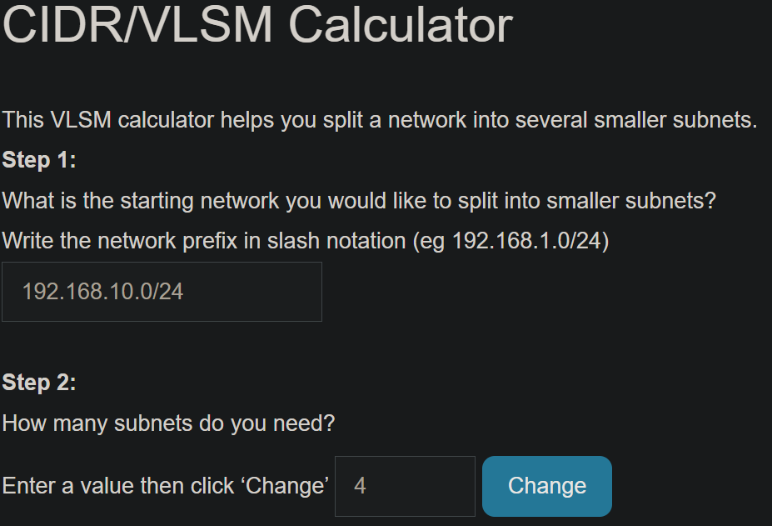
Figure 1: VLSM Calculator - Step 1: Base network 192.168.10.0/24, 4 subnets required.
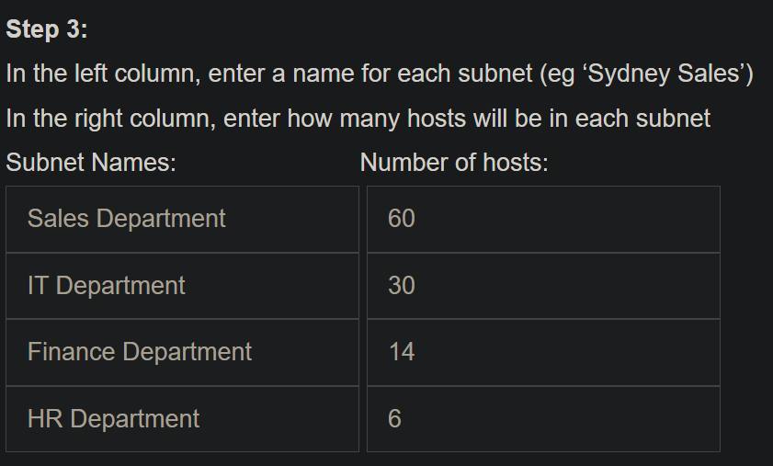
Figure 2: VLSM Calculator - Step 3: Host count entry for Sales (60), IT (30), Finance (14), HR (6).
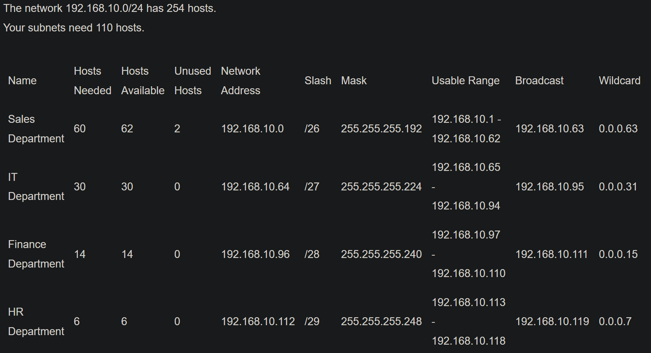
Figure 3: VLSM Calculator - Results: Complete subnet allocation table with network addresses, masks, usable ranges, broadcasts, and wildcard masks.

VLSM Subnet Summary Table - 192.168.10.0/24
Department | VLAN | Network Address | Subnet Mask | Usable Range | Broadcast
Sales | 10 | 192.168.10.0 | /26 - 255.255.255.192 | 192.168.10.1 - .62 | 192.168.10.63
IT | 20 | 192.168.10.64 | /27 - 255.255.255.224 | 192.168.10.65 - .94 | 192.168.10.95
Finance | 30 | 192.168.10.96 | /28 - 255.255.255.240 | 192.168.10.97 - .110 | 192.168.10.111
HR | 40 | 192.168.10.112 | /29 - 255.255.255.248 | 192.168.10.113 - .118 | 192.168.10.119

Note: The First Usable IP of each subnet was assigned to the Main Router sub-interfaces to serve as the default gateway for that VLAN (e.g., 192.168.10.1 for Sales, 192.168.10.65 for IT, 192.168.10.97 for Finance, 192.168.10.113 for HR).

3. Network Architecture & Tier Identification
The physical and logical topology was designed using the Cisco Three-Tier Hierarchical Model to isolate fault domains, streamline traffic flow, and enable independent scaling of each tier. Devices were carefully placed based on their Layer 2 or Layer 3 capabilities and their functional role within the enterprise.

3.1 Initial Topology Design
The initial topology layout was constructed in Cisco Packet Tracer, establishing the physical connectivity between all devices before configuration. This baseline confirms all cable connections are correct before any logical configuration is applied.

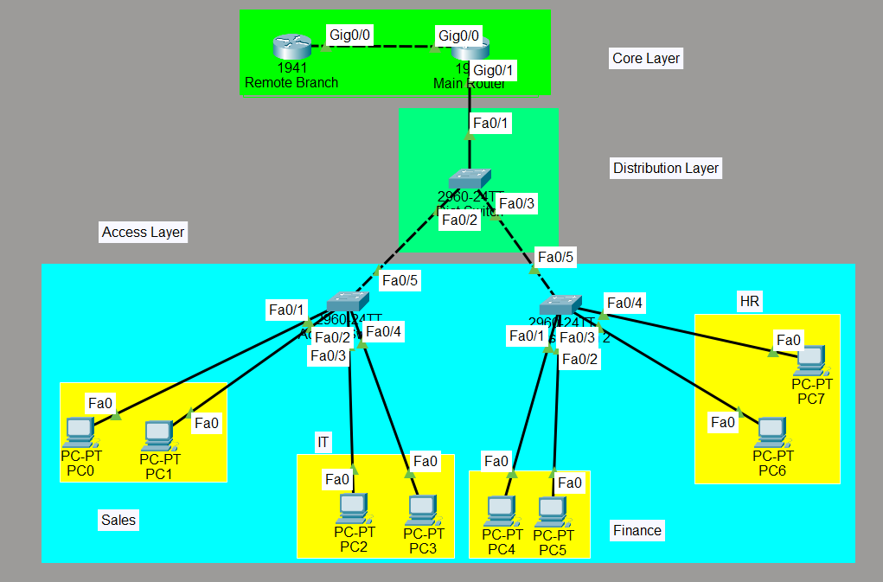
Figure 4: Initial Cisco Packet Tracer topology - physical cabling complete, colour-coded layer groupings visible.

3.2 Final Labelled Topology
The final topology with all tier labels applied is shown below. The Core, Distribution, and Access layers are clearly delineated with background colour groupings, matching the hierarchical model requirement of the assignment.

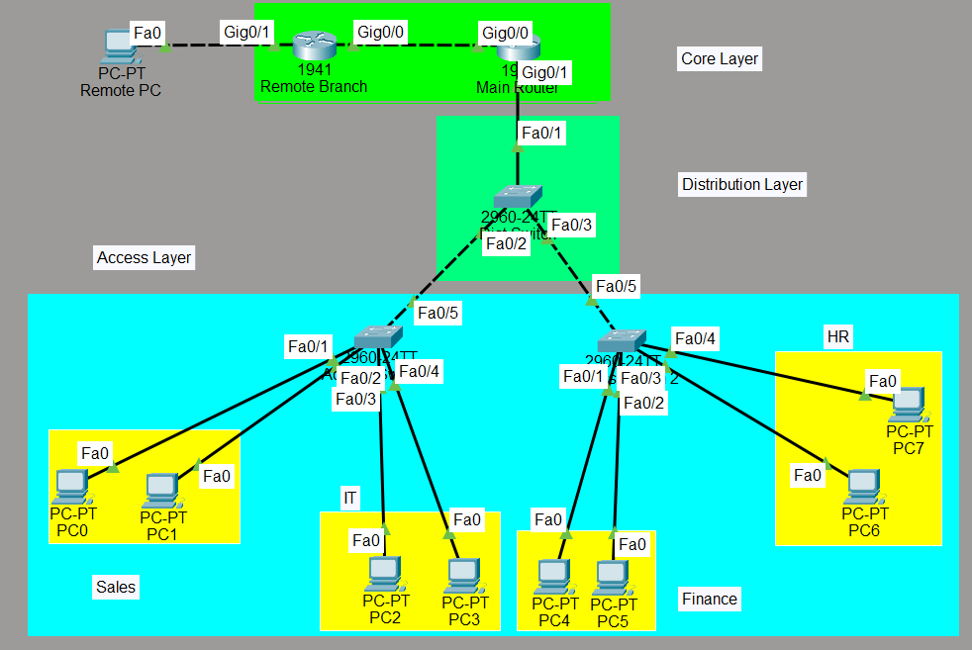
Figure 5: Final labelled topology - Core (green), Distribution (green), Access (cyan) with departmental VLAN colour groupings (Sales, IT, Finance, HR in yellow).

3.3 Device Role Justification
Tier | Device(s) | Layer | Why Placed Here
Core / Aggregation Block | Main Router (1941)  Remote Branch Router (1941) | Layer 3 - Routing + inter-VLAN gateway | Only the router has the Layer 3 intelligence to perform inter-VLAN routing (ROAS), apply Extended ACLs, and exchange static routes with the Remote Branch.
Distribution Block | Dist Switch (2960-24TT) | Layer 2 - Trunk aggregation | Aggregates trunk uplinks from both Access Switches and passes all VLAN-tagged frames to the router. Does not connect directly to any end-user device.
Access Block | Access Switch 1 (2960)  Access Switch 2 (2960)  All PCs (PC0-PC7)  Remote PC | Layer 2 - Edge access | Provides port-level endpoint connectivity. VLAN membership is enforced here via access ports. Trunk ports carry tagged frames up to the Distribution Switch.

4. Switch Configurations - VLANs & Trunking
To achieve logical segmentation of the four departments, VLANs were created and applied across the switching infrastructure. Each access switch is responsible for its own set of VLANs, with a dedicated trunk port connecting upward to the Distribution Switch.

4.1 Access Switch 1 - Sales (VLAN 10) & IT (VLAN 20)
Parameter | VLAN 10 - Sales | VLAN 20 - IT
VLAN ID | 10 | 20
VLAN Name | Sales | IT
Access Ports | Fa0/1 – Fa0/2 | Fa0/3 – Fa0/4
Trunk Port | Fa0/5 (uplink to Dist Switch) | Fa0/5 (shared trunk)
Connected Hosts | PC0, PC1 | PC2, PC3

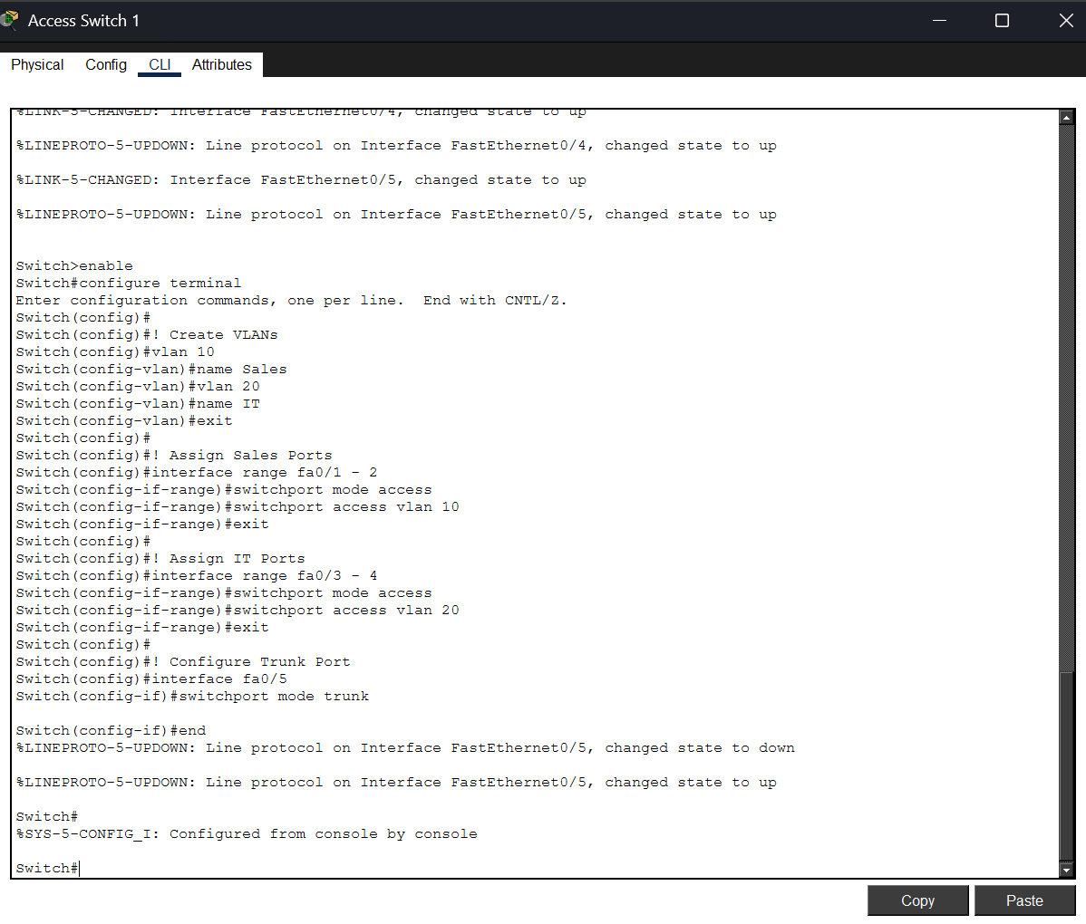
Figure 6: Access Switch 1 CLI - VLAN 10 (Sales) on Fa0/1–2, VLAN 20 (IT) on Fa0/3-4, trunk on Fa0/5.

4.2 Access Switch 2 - Finance (VLAN 30) & HR (VLAN 40)
Parameter | VLAN 30 — Finance | VLAN 40 — HR
VLAN ID | 30 | 40
VLAN Name | Finance | HR
Access Ports | Fa0/1 – Fa0/2 | Fa0/3 – Fa0/4
Trunk Port | Fa0/5 (uplink to Dist Switch) | Fa0/5 (shared trunk)
Connected Hosts | PC4, PC5 | PC6, PC7

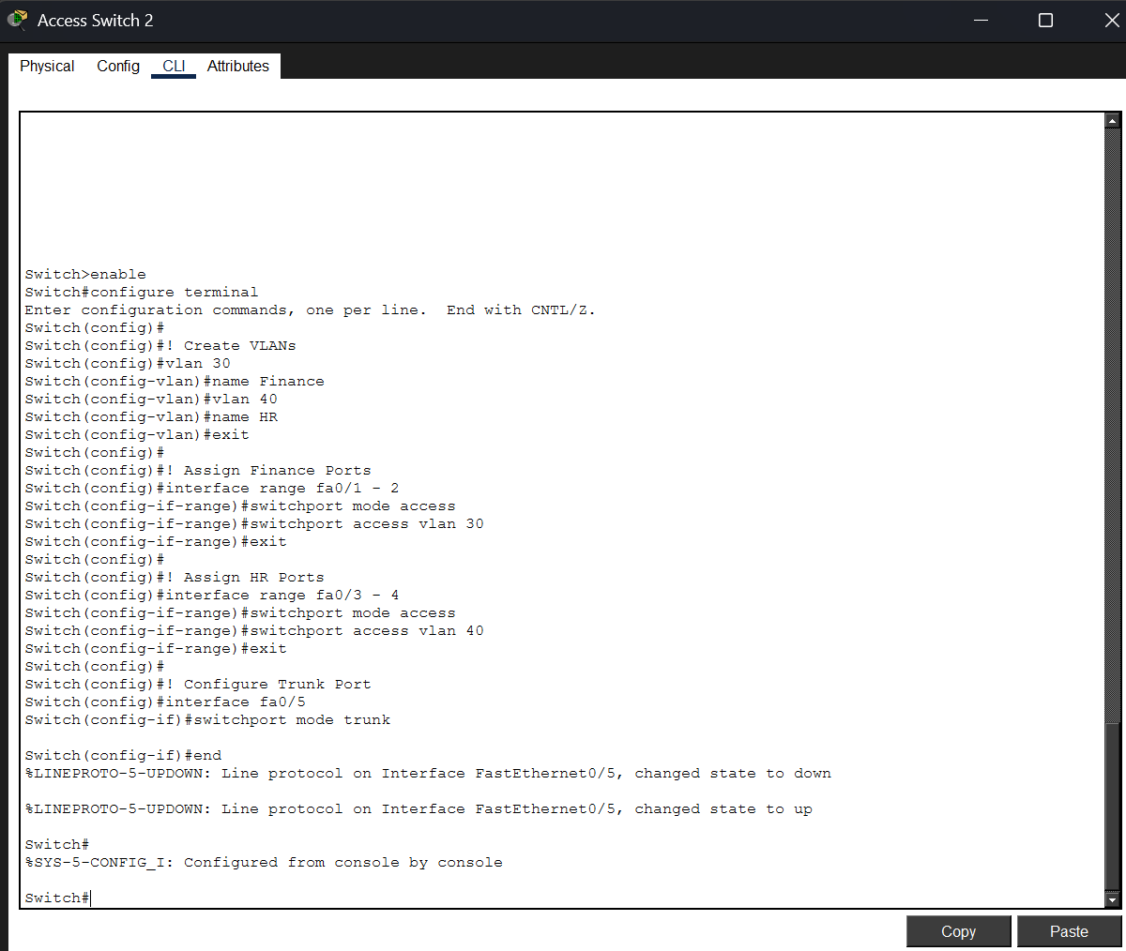
Figure 7: Access Switch 2 CLI - VLAN 30 (Finance) on Fa0/1–2, VLAN 40 (HR) on Fa0/3–4, trunk on Fa0/5.

4.3 Distribution Switch
The Distribution Switch does not connect to any end-user devices directly. Its sole function is to aggregate trunk links from both Access Switches and pass all VLAN-tagged traffic to the Main Router via a trunk uplink. All four VLANs (10, 20, 30, 40) are added to its local VLAN database, and all active interfaces (Fa0/1, Fa0/2, Fa0/3) are set to trunk mode.

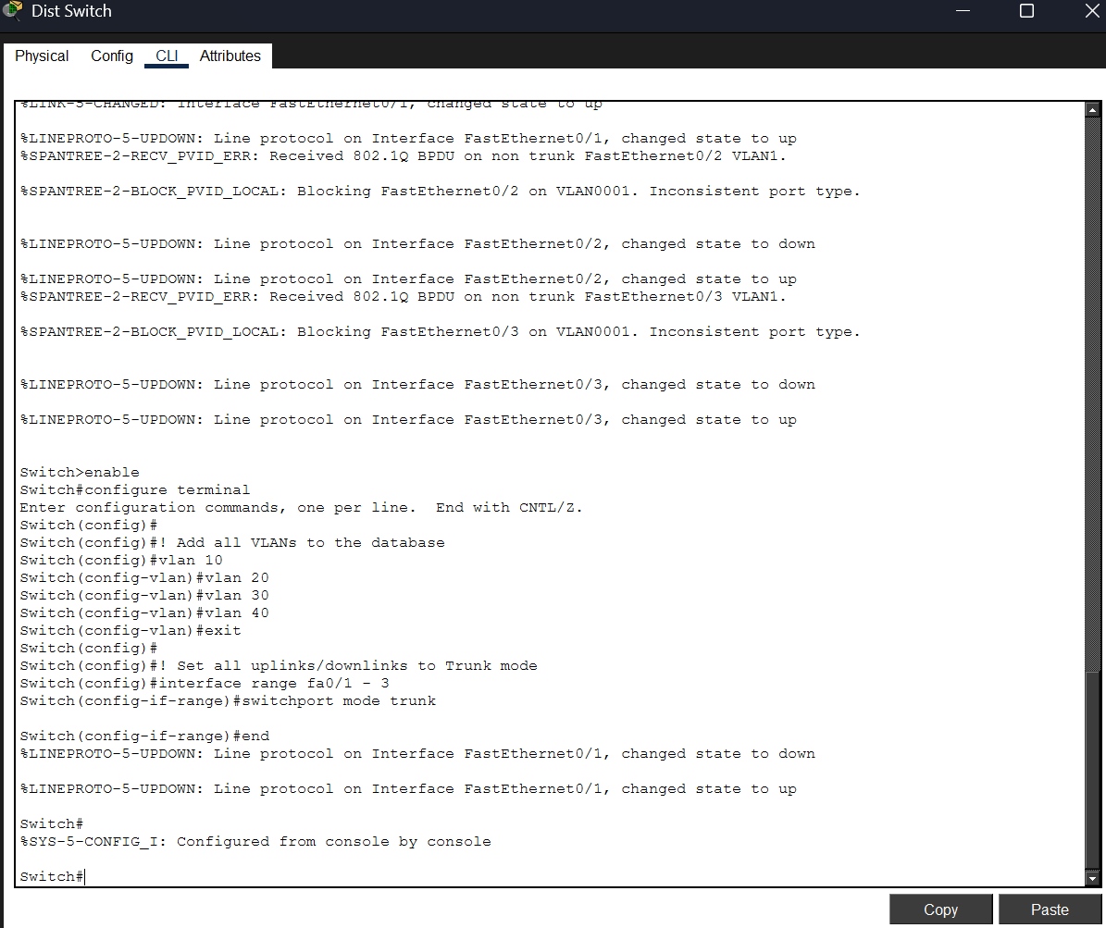
Figure 8: Distribution Switch CLI - VLANs 10/20/30/40 created; Fa0/1–3 set to trunk mode (PVID errors resolved after trunk applied).

5. Router Configurations - ROAS & Remote Branch

5.1 Main Router - ROAS Sub-Interfaces
To enable inter-VLAN communication without a Layer 3 switch, the Router-on-a-Stick (ROAS) technique was applied on the Main Router's Gig0/1 interface. Four logical sub-interfaces were created, each encapsulated with an 802.1Q tag matching its VLAN ID, and each assigned the First Usable IP of its respective subnet as the default gateway.
Sub-Interface | VLAN | Encapsulation / IP | Subnet Mask | Gateway For
Gig0/1.10 | VLAN 10 | dot1Q 10 / 192.168.10.1 | /26 | Sales
Gig0/1.20 | VLAN 20 | dot1Q 20 / 192.168.10.65 | /27 | IT
Gig0/1.30 | VLAN 30 | dot1Q 30 / 192.168.10.97 | /28 | Finance
Gig0/1.40 | VLAN 40 | dot1Q 40 / 192.168.10.113 | /29 | HR

Figure 9: Main Router CLI - ROAS sub-interfaces Gig0/1.10/.20/.30/.40 configured with 802.1Q encapsulation and department gateway IPs. Sub-interfaces confirmed up.

5.2 Main Router - Remote Branch WAN Link
A dedicated WAN link was established between the Main Router and the Remote Branch router using a /30 point-to-point subnet (10.0.0.0/30). The Main Router's Gig0/0 interface was assigned 10.0.0.1/30, and the Remote Branch's Gig0/0 was assigned 10.0.0.2/30. This creates a minimal, non-wasteful 2-host subnet for the router-to-router link.

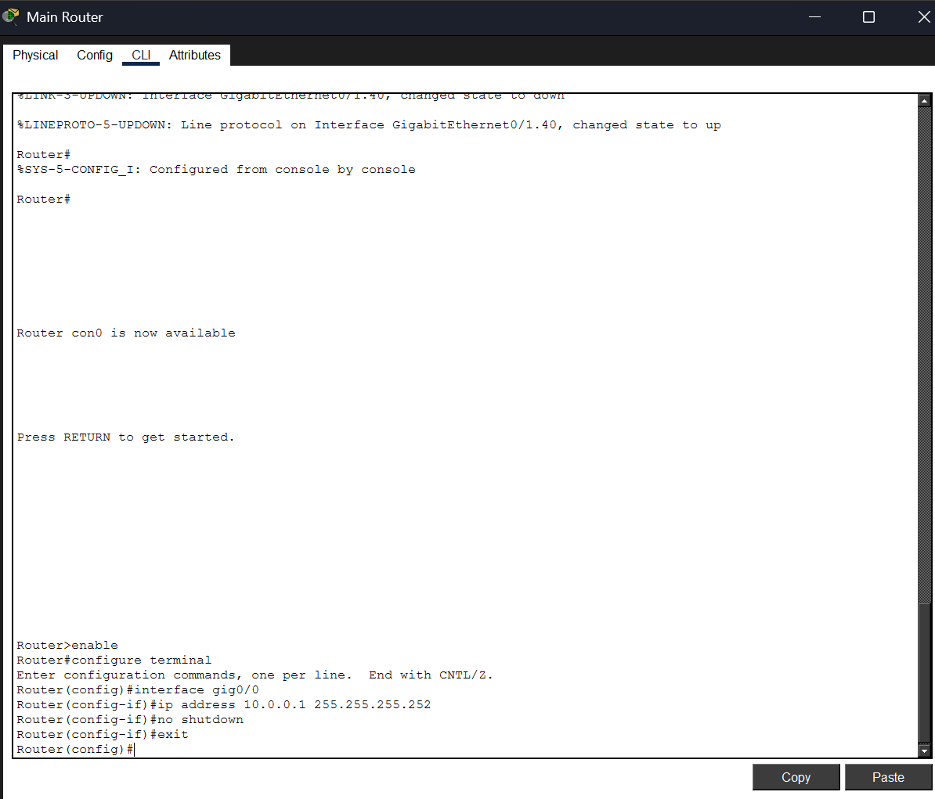
Figure 10: Main Router CLI - Gig0/0 configured with WAN address 10.0.0.1/30 for the Remote Branch point-to-point link.

5.3 Remote Branch Router
The Remote Branch router simulates an external office location. Its Gig0/0 interface (10.0.0.2/30) faces the Main Router over the WAN link, while its Gig0/1 interface (192.168.20.1/24) acts as the default gateway for the Remote LAN (192.168.20.0/24), which hosts the Remote PC (192.168.20.2).

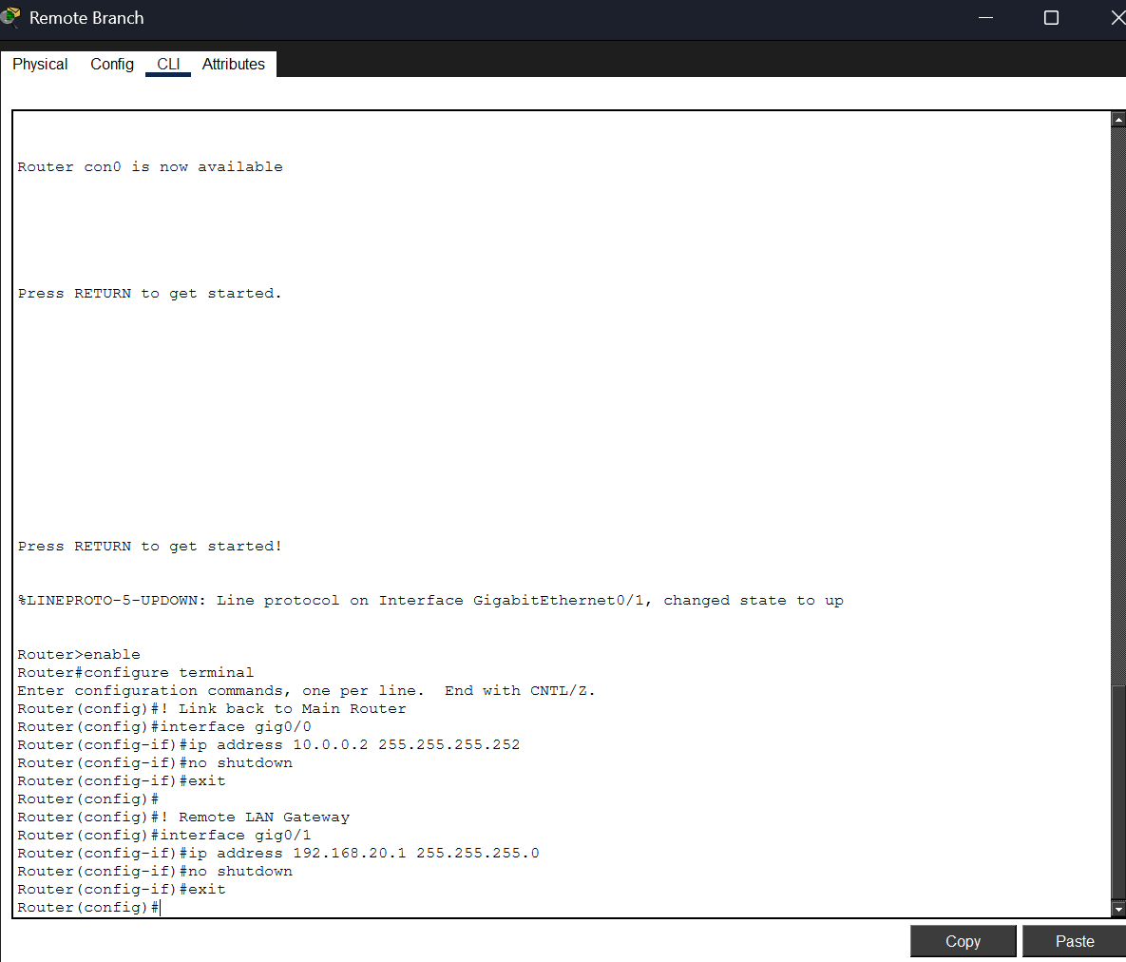
Figure 11: Remote Branch Router CLI - Gig0/0 (10.0.0.2) WAN interface; Gig0/1 (192.168.20.1) local LAN gateway for the remote subnet.

6. Reachability & Access Control - Static Routing + ACLs
To satisfy the specific security and reachability policy of TechNova Solutions, two mechanisms were combined: Static Routing for inter-site reachability, and an Extended Access Control List (ACL) to enforce departmental traffic restrictions.

Policy | Implementation
IT → Full Reachability | No ACL restrictions applied to VLAN 20 traffic. IT can reach all VLANs and the Remote Branch freely via the ROAS router.
Finance → HR (Allowed) | Finance (192.168.10.96/28) and HR (192.168.10.112/29) can reach each other - ACL only blocks their access to Sales.
Finance → Sales (BLOCKED) | ACL 100 explicitly denies traffic from 192.168.10.96/28 (Finance wildcard 0.0.0.15) to the Sales subnet (192.168.10.0/26).
HR → Sales (BLOCKED) | ACL 100 explicitly denies traffic from 192.168.10.112/29 (HR wildcard 0.0.0.7) to the Sales subnet.
All Others (Permitted) | ACL 100 ends with 'permit ip any any' - all other traffic not matched by the deny statements is forwarded normally.
ACL Application Point | ACL 100 is applied OUTBOUND on Gig0/1.10 (the Sales sub-interface) - traffic is checked only when exiting toward Sales.

6.1 Remote Branch Default Route
A static default route (ip route 0.0.0.0 0.0.0.0 10.0.0.1) was configured on the Remote Branch router. This instructs the Remote Branch to forward all traffic destined for unknown networks (including any internal enterprise subnet) toward the Main Router at 10.0.0.1.

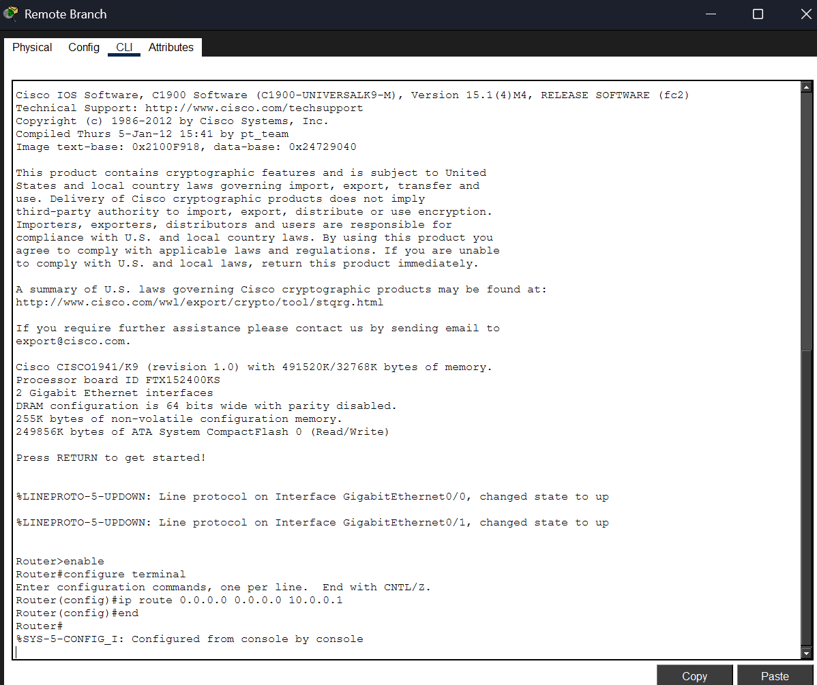
Figure 12: Remote Branch Router - default static route 0.0.0.0/0 via 10.0.0.1 ensures all outbound traffic is forwarded to the Main Router.

6.2 Main Router - Static Route + Extended ACL
On the Main Router, a static route was added to reach the Remote Branch LAN (192.168.20.0/24) via the next-hop 10.0.0.2. Additionally, Extended ACL 100 was created with three statements: deny Finance to Sales, deny HR to Sales, and permit all other traffic. The ACL was then applied outbound on the Sales sub-interface (Gig0/1.10).

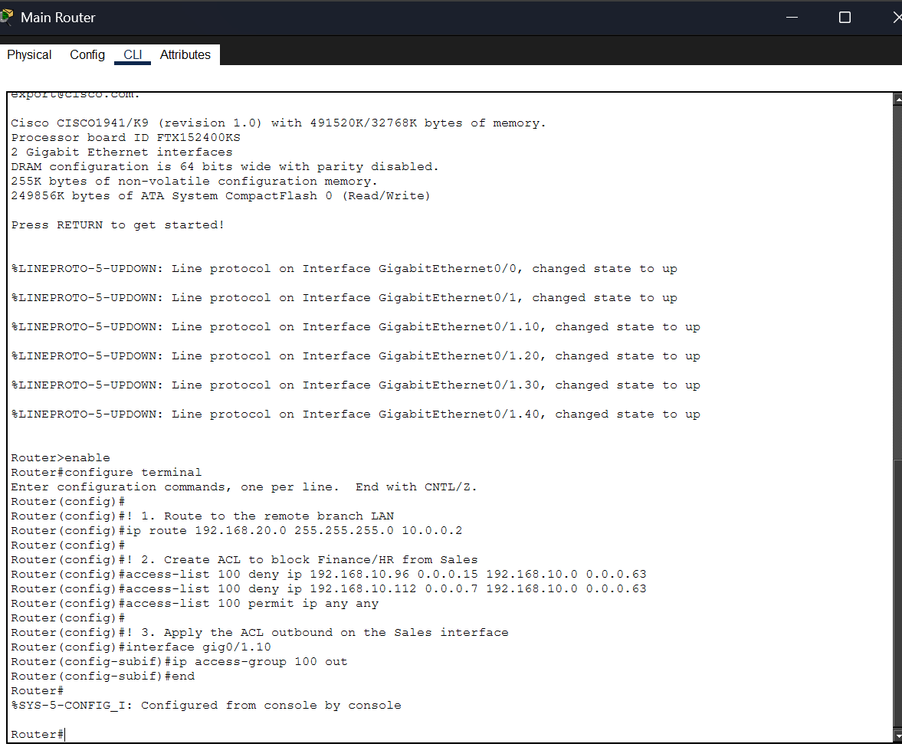
Figure 13: Main Router CLI - static route to 192.168.20.0/24 via 10.0.0.2; ACL 100 with deny Finance/HR to Sales, permit any; ACL applied outbound on Gig0/1.10.

7. Connectivity Verification - Ping Tests
All ping tests were conducted from representative PCs within each department to confirm that the routing, VLAN, and ACL configurations are operating exactly as designed. The first packet loss in each test is normal - it is consumed by the ARP resolution process.

7.1 IT Department - Full Reachability
The IT Department (VLAN 20, subnet 192.168.10.64/27) must have unrestricted access to all other departments and the Remote Branch. Tests were initiated from an IT PC (192.168.10.66).

Source | Destination | Expected | Result
IT PC (192.168.10.66) | Sales PC - 192.168.10.2 | SUCCESS (IT not blocked) | ✓ 3/4 packets - TTL=127
IT PC (192.168.10.66) | Remote PC - 192.168.20.2 | SUCCESS (full reachability) | ✓ 3/4 packets - TTL=127

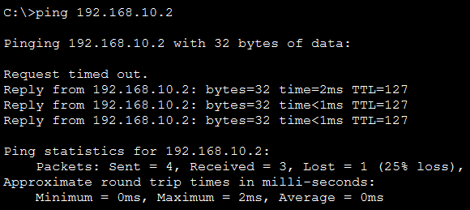
Figure 14a: IT PC → Sales (192.168.10.2) - 3/4 success (first packet = ARP miss). TTL=127 confirms routing via Main Router.
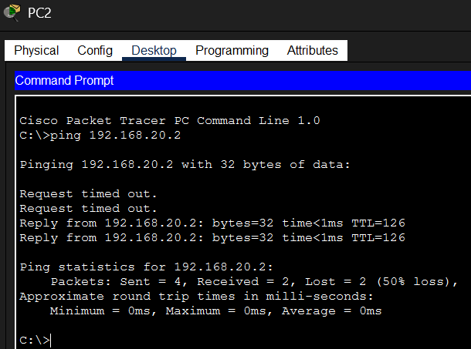
Figure 14b: IT PC → Remote PC (192.168.20.2) - 3/4 success. TTL=127 confirms two routing hops (Main Router + Remote Branch).

7.2 Finance & HR - Restricted Reachability
The Finance (VLAN 30 - 192.168.10.96/28) and HR (VLAN 40 - 192.168.10.112/29) departments must be able to communicate with each other freely, but all traffic from Finance or HR destined for the Sales subnet must be blocked by ACL 100 on the Main Router.

Source | Destination | Expected | Result
Finance PC (192.168.10.98) | HR PC - 192.168.10.114 | SUCCESS (Finance→HR allowed) | ✓ 2/4 packets - TTL=126
Finance PC (192.168.10.98) | Sales PC - 192.168.10.2 | BLOCKED by ACL 100 | ✗ Dest. Host Unreachable - 100% loss

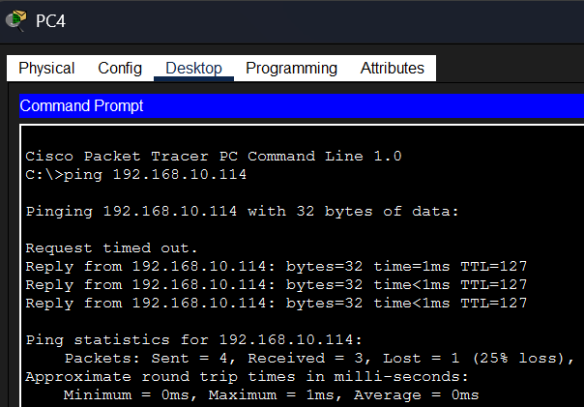
Figure 15a: Finance PC → HR (192.168.10.114) - 2/4 success (first 2 pkts = ARP+route learning). Communication between Finance and HR is allowed.
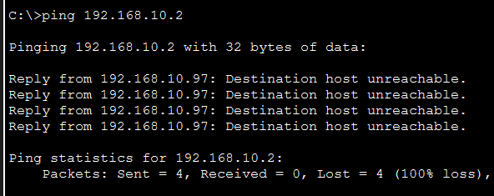
Figure 15b: Finance PC → Sales (192.168.10.2) - 100% blocked. Main Router returns 'Destination host unreachable' - ACL 100 is enforcing the policy correctly.
How ACL 100 Works
access-list 100 deny ip 192.168.10.96 0.0.0.15 192.168.10.0 0.0.0.63
→ Denies: any source from Finance (.96–.111) to Sales (.0–.63)
access-list 100 deny ip 192.168.10.112 0.0.0.7 192.168.10.0 0.0.0.63
→ Denies: any source from HR (.112–.119) to Sales (.0–.63)
access-list 100 permit ip any any
→ Permits: all other traffic (IT, Sales self-traffic, Remote Branch, etc.)

8. Conclusion
This mid-term assignment successfully demonstrated the complete design, configuration, and validation of an enterprise-grade small branch network for TechNova Solutions using Cisco Packet Tracer. Five distinct technical competencies were exercised and verified:

✓ | Achievement
✓ | VLSM Subnetting: The 192.168.10.0/24 block was efficiently divided into four variable-length subnets - /26 (Sales), /27 (IT), /28 (Finance), and /29 (HR) - eliminating IP waste and precisely matching each department's host requirements.
✓ | Hierarchical Network Design: The topology was built and correctly labelled across three tiers: Core/Aggregation (Main Router + Remote Branch Router), Distribution (Dist Switch), and Access (Access SW1, SW2, and all PCs). Each device placement was justified by its Layer 2/3 capabilities.
✓ | VLAN Segmentation: Four VLANs (10 Sales, 20 IT, 30 Finance, 40 HR) were created and applied across both Access Switches. Trunk ports correctly carry all tagged VLAN frames between the Access layer, Distribution Switch, and Main Router.
✓ | Router-on-a-Stick (ROAS): Inter-VLAN routing was achieved on the Main Router using 802.1Q sub-interfaces (Gig0/1.10 through .40), enabling communication between all four departmental VLANs through a single physical router interface.
✓ | Static Routing: A point-to-point /30 WAN link (10.0.0.0/30) was established between the Main Router and the Remote Branch. Static routes were configured on both sides to ensure bi-directional reachability between the enterprise LAN and the Remote LAN (192.168.20.0/24).
✓ | Extended ACL Security: ACL 100 enforces TechNova's reachability policy - Finance and HR are blocked from reaching Sales (100% packet drop confirmed), while their mutual communication is preserved. IT retains full unrestricted access across all segments. All policies were verified with live ping tests.

This mid-term assignment brought together all networking concepts covered in Weeks 1 through 5 of the CYBERSTER internship - from Layer 1 physical cabling and Layer 2 VLAN segmentation to Layer 3 routing, subnetting mathematics, and security policy enforcement via ACLs. The successful verification of all ping tests confirms that the TechNova Solutions network is fully operational, correctly segmented, and properly secured - ready to serve the enterprise's four departments and its remote branch location.

